Pupil premium strategy statement

This statement details our school’s use of pupil premium (and recovery premium for the 2021 to 2022 academic year) funding to help improve the progress, attainment, and well-being of disadvantaged pupils in our school.

It outlines our pupil premium strategy, how we intend to spend the funding in this academic year and the effect that last year’s spending of pupil premium had on our disadvantaged pupils.

School overview
Detail | Data
School name | Easebourne CE Primary School
Number of pupils in school | 225
Proportion (%) of pupil premium eligible pupils | 15%
Academic year/years that our current pupil premium strategy plan covers (3 year plans are recommended) | 2021/22  2022/23  2023/24
Date this statement was published | 17th December, 2021
Date on which it will be reviewed | 17th December, 2022
Statement authorised by | Johnny Culley
Pupil premium lead | Caroline Hulbert
Governor / Trustee lead | Vickie Hampshire
Funding overview
Detail | Amount
Pupil premium funding allocation this academic year | £ 42,692
Recovery premium funding allocation this academic year | £ 1,087
Pupil premium funding carried forward from previous years (enter £0 if not applicable) | £12, 642
Total budget for this academic year  If your school is an academy in a trust that pools this funding, state the amount available to your school this academic year | £ 56,241

Part A: Pupil premium strategy plan

Statement of intent
We will deliver a broad ambitious curriculum to all pupils.
High quality teaching will enable our disadvantaged and vulnerable children to make good progress in all subjects.
ALL children will be able to read fluently by the time they leave EPS in Year 6*.
We will support children to develop wider interests, to explore different interests and develop their dreams.
No disadvantaged child will suffer from digital poverty.
Our strategy is based on an evidence-based approach, is tiered and manageable.
Progress against our objectives will be evaluated on a termly basis.
*Our SEND children will make good progress, but may not reach age expected goals including reading fluently

Challenges

This details the key challenges to achievement that we have identified among our disadvantaged pupils.
Challenge number | Detail of challenge
1 | Lack of parental engagement to support reading and other forms of homework
2 | Low attainment / poor progress – ACEs (Adverse Childhood Experiences)
3 | Less cultural capital from home environment, no one to share experiences with
4 | Low self-esteem / lack of resilience / lack of ambition
5 | Attendance is often irregular for some disadvantaged children

Intended outcomes
This explains the outcomes we are aiming for by the end of our current strategy plan, and how we will measure whether they have been achieved.
Intended outcome | Success criteria
Improve teaching quality in all subjects | Sticky learning evident through pupil voice / work scrutiny in all subjects. Disadvantaged children known more, do more and remember more
Children will read fluently by the time they leave at the end of KS2 (Year 6) | Fluency will improve over time. Children will be supported as needed with phonic interventions; they will be our priority to read with an adult; they will gain strategies to develop their reading independently
Improved attendance because children want to come to school | Children’s % attendance will increase.  Children’s progress will improve because they are in school more often.
Children can learn at home independently where support is lacking or not in place at all. | Devices supplied to enable independent practice at home.  Children will be monitored on how they engage in programmes such as Lexia, TTRS (Times Tables Rockstars), Online spelling at home  Children can access homework and additional resources in Google Classrooms  Additional logs ins for Collins e-books / EPIC - reading resources (including read along books) will be provided
Children explore and experiment with a wide range of different experiences to establish what they like, what they are good at and what they enjoy outside of regular classroom learning – developing self-esteem & resilience | Ensure children have access to and equipment for Forest School, School trips, Clubs and music lessons
Children are able to enjoy and discuss shared experiences outside of their home environment | Children have opportunities for discussion via a well-structured coherent and progressive curriculum  School council, Rights Respecting Schools, Eco Committee
Disadvantaged children make good progress year on year (gaps are reduced over time and targeted early on) | Quality First Teaching / Rosenshine – metacognition / 7C’s  Work scrutiny would be even across disadvantaged and non-disadvantaged groups not identify PP – all able to succeed and excel.  Children make good progress and reach their potential.  Disadvantaged children are prioritised for 1:1 tutoring funding from the DfE
Children can make mistakes and learn from them without worrying | 7 C’s  SEMH support is appropriate, timely and useful in re-building low self-esteem and supporting children to become resilient
SEMH (Social, Emotional and Mental Health) needs are met | Children in need of additional support for SEMH would be offered Play therapy or ELSA (Emotional Literacy Support Assistant)

Activity in this academic year
This details how we intend to spend our pupil premium (and recovery premium funding) this academic year to address the challenges listed above. EEF is the Education Endowment Fund and the impact of the activity/approach is shown. For example, +4 is a gain of 4 months progress over an academic year.

High quality teaching
Budgeted cost: £ 29,357.03

Activity | Evidence that supports this approach | Challenge number(s) addressed
Teaching | High quality Teaching  (Curriculum / feedback +6)  Mastery learning – Maths +5  Metacognition +7 | 1,3, 4,5
Reading (early reading / phonics and reading comprehension) | Phonics and Early Reading  Rich Texts in all subjects  Reading comprehension strategies (Whole Class Reading)  Daily modelled reading by Class Teachers  EEF +6 | 1,3, 4,5
Curriculum | High quality teaching through training access to high quality resources / planning  Metacognition CPD | 1,3, 4,5

Targeted academic support (for example, tutoring, one-to-one support structured interventions)
Budgeted cost: £ 20,262.42

Activity | Evidence that supports this approach | Challenge number(s) addressed
Phonics – structured intervention | EEF +5 | 1,3, 4,5
Tutoring * cost of this tbc | EEF +5  1:1 (Spring 1)  25% of Tutoring funding | 1,3, 4,5
Lexia | After using Core5 for the school year, students were 2x more likely than non-users to be proficient readers.  Core5 was 64% more effective than comparable programs as measured by standardized assessment growth. | 1,3, 4,5
Mentoring (ELSA) | EEF +4  Improved learning / self-esteem / sharing experiences | 1,3,4,5
Counselling | Play Therapy (3 terms) | 1,3, 4,5
Alternative Provision | EEF +4
Digital Poverty | Providing loan Chromebooks to all disadvantaged children in our school (34 devices) | 2

Wider strategies (for example, related to attendance, behaviour, wellbeing)
Budgeted cost: £ 5,730.36

Activity | Evidence that supports this approach | Challenge number(s) addressed
Forest School | EEF (insufficient data)  Improved self-esteem / cultural capital | 1,3,4,5
Clubs | Improved self-esteem / cultural capital / developing friendships | 1,3,4,5
Music Lessons | Improved self-esteem / cultural capital | 1,3,4,5
Subsidised trips | Improved self-esteem / cultural capital / developing friendships | 1,3,4,5

Total budgeted cost: £ 55,349.81

Part B: Review of outcomes in the previous academic year

Pupil premium strategy outcomes
This details the impact that our pupil premium activity had on pupils in the 2020 to 2021 academic year.
We did not spend the full pupil premium budget last year due to Covid. We had a large carry forward for this year (£12,000) which is being used to reduce digital poverty for our disadvantaged pupils (this will be a one-off purchase).
Data below shows that our Recovery Curriculum supported disadvantaged pupils to make progress, although this was at a significantly lower rate to non-disadvantaged pupils, particularly in Reading. PP funding included supporting our Remote Learning via Google Classrooms (CPD, hardware). Additional Play Therapy Spaces were also funded to support our most vulnerable children during the Covid disruption.
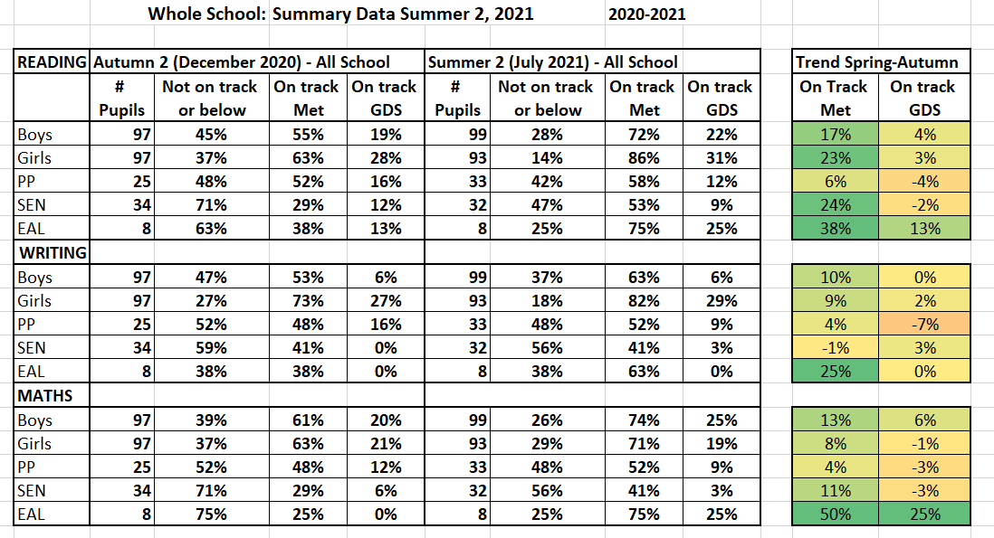

Externally provided programmes
Please include the names of any non-DfE programmes that you purchased in the previous academic year. This will help the Department for Education identify which ones are popular in England
Programme | Provider
Pira (moving to Cornerstones) | Hodder
Puma (moving to NCETM) | Hodder
Accelerated Reader | Renaissance
Comparative Judgement | No more marking

Further information (optional)
We hope to use the 1:1 Tutoring funding to support our disadvantaged children in the Spring Term and will be using PP funding for the initial 25% as advised by our County Finance Team.

