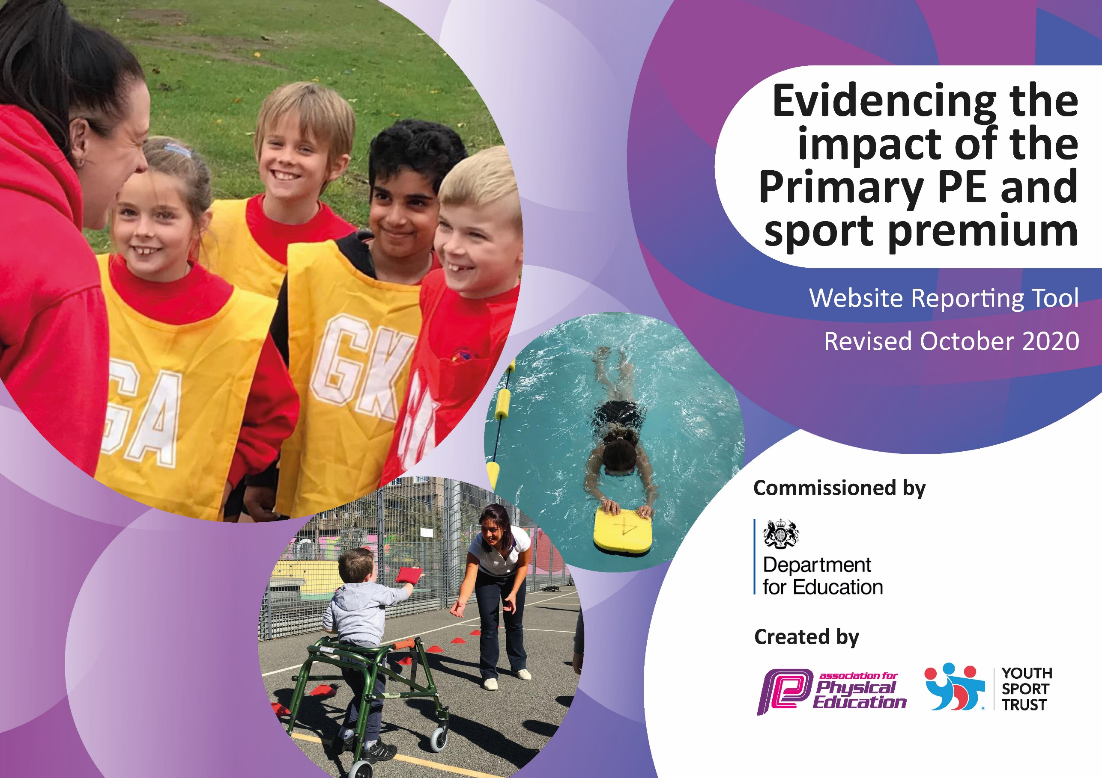
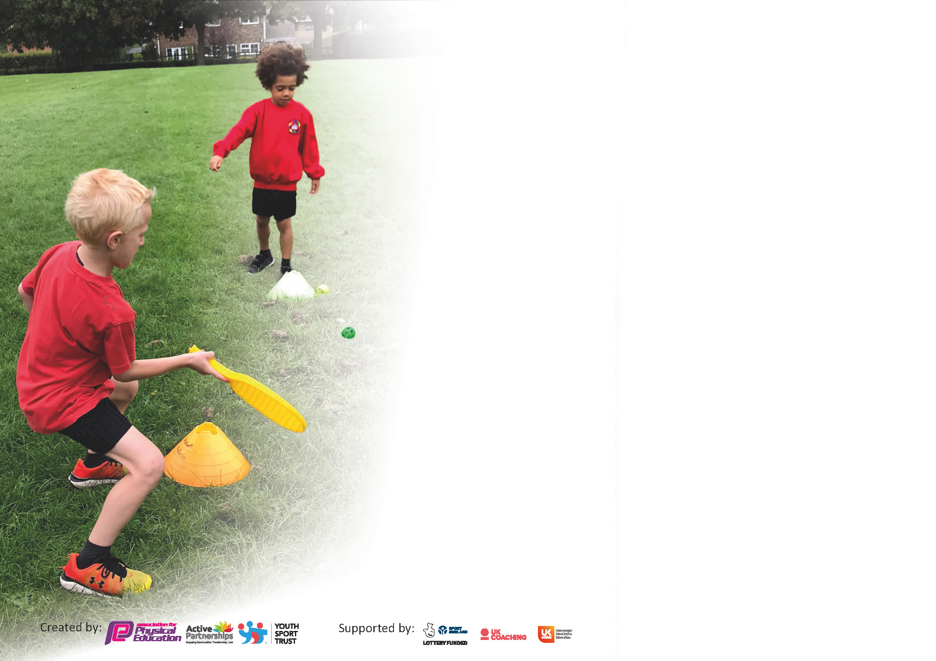

It is important that your grant is used effectively and based on school need. The Education Inspection Framework (Ofsted 2019 p64) makes clear there will be a focus on ‘whether leaders and those responsible for governors all understand their respective roles and perform these in a way that enhances the effectiveness of the school’.

Under the Quality of Education criteria (p41) inspectors consider the extent to which schools can articulate their curriculum (INTENT), construct their curriculum (IMPLEMENTATION) and demonstrate the outcomes which result (IMPACT).

To assist schools with common transferable language this template has been developed to utilise the same three headings which should make your plans easily transferable between working documents.

Schools must use the funding to make additional and sustainable improvements to the quality of Physical Education, School Sport and Physical Activity (PESSPA) they offer. This means that you should use
the Primary PE and sport premium to:

- Develop or add to the PESSPA activities that your school already offer
- Build capacity and capability within the school to ensure that improvements made now will benefit pupils joining the school in future years

Please visit gov.uk for the revised DfE guidance including the 5 key indicators across which schools should demonstrate an improvement. This document will help you to review your
provision and to report your spend. DfE encourages schools to use this template as an effective way of meeting the reporting requirements of the Primary PE and sport premium.

We recommend you start by reflecting on the impact of current provision and reviewing the previous spend.

Schools are required to publish details of how they spend this funding as well as on the impact it has on pupils’ PE and sport participation and attainment by the end of the summer term or by 31st July 2021 at the latest.

** In the case of any under-spend from 2019/20 which has been carried over this must be used and published by 31st March 2021.

We recommend regularly updating the table and publishing it on your website throughout the year. This evidences your ongoing self-evaluation of how you are using the funding to secure maximum, sustainable impact. Final copy must
be posted on your website by the end of the academic year and no later than the 31st July 2021. To see an example of how to complete the table please click HERE.
Created by: Supported by:

Please note: Although there has been considerable disruption in 2020 it is important that you publish details on your website of how you spend the funding - this is a legal requirement.
Support for review and reflection - considering the 5 key indicators from DfE, what development needs are a priority for your setting and your pupils now and why? Use the space below to reflect on previous spend and key achievements and areas for development.

N.B. In this section you should refer to any adjustments you might have made due to Covid-19 and how these will influence further improvement.
Key achievements to date until July 2021: | Areas for further improvement and baseline evidence of need:
- Quality start award – KS1 (Silver level approved)  - Tree Top Toddlers embedded for key skills with Dragonflies (EYFS)  - School Games Mark Award (Silver) and commitment award for academic year 19/20 (covid related)  - PE/Sport delivered across school through confident teachers and within bubbles throughout covid times  - Equipment purchased and shared within bubbles  - Easebourne offers a wide range of extra-curricular sports clubs and the numbers of children attending these clubs is increasing  - Children involved in choosing sports that they would like to see as extra-curricular (through school council)  - School council and as a result, whole class involvement in deciding on new equipment (through assemblies etc)  - Access to competitions outside of school in both KS1 and KS2 (until we couldn’t attend any more)  - More opportunities to compete in Level 1 and 2 sports competitions  - KS1 engagement in PE/Sport increased significantly  - Daily mile implemented and successfully running 4 days a week (until Covid)  - Observation of agency staff resulting in change of staff and as a result happier and more children in engaged in PPA covered PE sessions  - More positive attitude to PE/Sport through both adults and children (encouraging an active lifestyle whilst home learning has helped parent support and children to view PE/Sport in a different way)  - More competitions being offered through the connections with other schools and the children want to be involved – KS1 children being offered more competitions (through private school and public school links) creating a positive outlook on healthy competition  - Holiday clubs being offered (in conjunction with Aspire and SCS – PP children invited at discount/ no cost) | - Planning – evidence of planning for PE across year groups (especially in KS2)  - Development of effective Sports Leaders (and playtime leaders) through ‘training’ sessions for children  - Maintain awards for school – quality start and school games mark  - Swimming provision to be succinct across all KS2 classes and be able to offer additional swimming sessions for those children in upper KS2 that need support (identified but difficulty following through with closure of swimming pools/ leisure centres)  - Offer change4life club to those that are less active than normal (target group of children)  - Assessment in PE to be rolled out across school  - Consistent delivery across all classes (with additional/ new staff joining the team) – being aware of expectation etc  - EYFS knowledge of PE/Sport co-ordinator, ensuring that there is a clear development of skills from EYFS to Year 6 rather than just from Year 1- 6  - Resources for new EYFS framework  - Level 6 award for PE coordinator  - Overview of PE/Sport clear with steps of progression and displayed  - Inclusive PE/Sport  - Skill/ application lessons being implemented from September 21 in connection with Aspire coaching

Did you carry forward an underspend from 2019-20 academic year into the current academic year?
YES * Delete as applicable

If YES you must complete the following section
If NO, the following section is not applicable to you

If any funding from the academic year 2019/20 has been carried over you MUST complete the following section. Any carried over funding MUST be spent by 31 March 2021.
Academic Year: September 2020 to March 2021 | Total fund carried over: £29,547 | Date Updated:  11.01.2021  28.07.21
What Key indicator(s) are you going to focus on?  - Engagement on all pupils in regular physical activity (through break time and lunch times being more active)  - The profile of PE/Sport is raised across the school as a tool for whole-school improvement |  |  |  | Total Carry Over Funding:
 |  |  |  | £29,547.00
Intent | Implementation |  | Impact
Your school focus should be clear how you want to impact on your pupils.  Purchase ‘trim trail’ equipment for field – intention is to encourage children to engage in more active play times when they have a wider selection of equipment to play on with climbing aspects as well as slides and monkey bars. This should help to get children to work together (when they can help one another) as well as to compete in individual tasks/ time trials to complete the challenge of the trim trail. | Make sure your actions to achieve are linked to your intentions:  - Quotes obtained from 3 different companies to install new play equipment for top field  - School council approached to deliver PE assemblies to help make a decision on the new equipment to be installed  - Pupil conferencing to make note of what the children would like to see  - Safety matting researched to ensure that children can use the equipment safely  - Children and staff involved in final decisions  - Date agreed for the work to go ahead in Spring term (2021) | Carry over funding allocated:  Total net cost: £24,000  (VAT @ £4,800) | Evidence of impact: How can you measure the impact on your pupils; you may have focussed on the difference that PE, SS & PA have made to pupils re-engagement with school. What has changed?:  Positive attitude from children who have been invited to be involved with the process of choosing, designing and negotiating prices with ‘Creative play’  Enhanced enjoyment of physical activity, teamwork skills and resilience developed – area for KS2 to keep active during break and lunch times (especially those that are not engaged with play time leader activities)  Children can share positive experiences of using the equipment, can challenge one another (without guidance from a TA/CT) and can enjoy using equipment | Sustainability and suggested next steps and how does this link with the key indicators on which you are focussing this academic year?:  Equipment purchased ensure that new and additional activities can continue and progress via both curricular and extra-curricular provision  Ensure that equipment is kept up to health and safety standards  Introduce children to ‘health and safety’ and allow them to carry out checks of equipment once a month with a CT or the School Premises manager  Somewhere for the children and staff of ‘Nurture’ room to have a break out area and allow children to complete challenges for themselves there (book time for them to use equipment)

Meeting national curriculum requirements for swimming and water safety.

N.B Complete this section to your best ability. For example you might have practised safe self-rescue techniques on dry land.
What percentage of your current Year 6 cohort swim competently, confidently and proficiently over a distance of at least 25 metres?  N.B. Even though your pupils may swim in another year please report on their attainment on leaving primary school at the end of the summer term 2021. | %
What percentage of your current Year 6 cohort use a range of strokes effectively [for example, front crawl, backstroke and breaststroke]? | %
What percentage of your current Year 6 cohort perform safe self-rescue in different water-based situations? | %
Schools can choose to use the Primary PE and sport premium to provide additional provision for swimming but this must be for activity over and above the national curriculum requirements. Have you used it in this way? | Yes/No

Action Plan and Budget Tracking
Capture your intended annual spend against the 5 key indicators. Clarify the success criteria and evidence of impact that you intend to measure to evaluate for pupils today and for the future.

Academic Year: 2020/21 | Total fund allocated: £ | Date Updated: 11.01.2021/ 28.07.21
Key indicator 1: The engagement of all pupils in regular physical activity – Chief Medical Officers guidelines recommend that primary school pupils undertake at least 30 minutes of physical activity a day in school |  |  |  | Percentage of total allocation:
 |  |  |  | %
Intent | Implementation |  | Impact
Your school focus should be clear what you want the pupils to know and be able to do and about  what they need to learn and to  consolidate through practice: | Make sure your actions to achieve are linked to your intentions: | Funding allocated: | Evidence of impact: what do pupils now know and what can they now do? What has changed?: | Sustainability and suggested next steps:
Opportunities in place to ensure that all children receive 60 minutes of physical activity a day (30 minutes of which are during the school day):  - Skip2bfit continues as a club (during covid)  - Equipment for play time leaders (including badges for leaders and storage unit to keep playtime leader equipment safe and together)  - Task cards to help playtime leaders  Change 4 life club to be introduced to help engage less active children  Swimming (Ks2) – offered to Year 4 as part of ‘catch up curriculum’ and this class missing out (Covid year)  Swimming (all of KS2)  Equipment for EYFS change in framework | Development of playground equipment and playtime leaders so that there is a variety of activities for a range of children (age ranges) to participate in  Ensure that playtime leaders and Sports leaders are helping during lunch and break times – running clubs, activities and leading warm ups/ stretches/ cool downs for example (in a club too) – playtime leader training to be introduced  Skip2bfit clubs to continue and new clubs to be introduced with Aspire coaching (x3 times a week)  Setting up Change4Life club to target less active children and invite children that are less active with the intention to pay for their attendance in the first instance  Contact made with Herons and the children were offered half an hour sessions of swimming for 6 weeks of the term. Every child in year 4 took up this offer.  Order to be placed with Early years company to ensure that each of the early years goals can be reached with the new goals | £44 (holdall)  Playground storage £  Training £  £700  £4,500  £3,985.22 | More active playtimes across the range of year groups (including EYFS)  Enriched lunchtimes with more children taking part in sporting activities  Varied programme of sporting for break/ lunchtimes within year group bubbles  Enhanced enjoyment of physical activity, teamwork skills and resilience developed  Relationships between lower and upper years increased through buddy encouragement system (with daily mile, covid dependent)  Change4Life club helping to target children but also educating parents with children about healthy lifestyles during sports and health week. Inviting parents to attend one of the club sessions (if a morning, before school club is offered) so that they can see ‘healthy mind, healthy me’ approach  50% more children in Year 4 confident swimmers and those that are still underconfident have been able to perform some form of water safety and are showing that they understand the dangers of water.  Safe equipment and enough for each child to benefit from this in order for each child to be given the opportunity to reach their EYFS goal under the new curriculum | Train children (each year) to become Sports leaders and playtime leaders to help develop more activities at lunchtimes (purchase of some target/ play cards to help playtime leaders with new ideas/ games)  Develop use of playground into zones (especially as children will be used to this after class bubble approach to break/ lunch times)  Maintain use of sports leaders/ play time leaders and ensure that they are happy to continue to coordinate this – alternative option is to have children from each class as playtime leaders during covid to allow for a wider selection of activities within your class and space on the playground  Introduce change4life through assembly, invite parents to sporting events to keep them engaged and help with healthy living and sporting world within school.  Covid ‘catch up’ system to be put in place for future year academic 21/22  Ensure that equipment is set up safely and is ready to access – to be kept in condition for other classes (future) to use
Key indicator 2: The profile of PESSPA being raised across the school as a tool for whole school improvement |  |  |  | Percentage of total allocation:
 |  |  |  | %
Intent | Implementation |  | Impact
Your school focus should be clear what you want the pupils to know and be able to do and about  what they need to learn and to  consolidate through practice: | Make sure your actions to achieve are linked to your intentions: | Funding allocated: | Evidence of impact: what do pupils now know and what can they now do? What has changed?: | Sustainability and suggested next steps:
Application for the Quality Start Award (KS1 2020-2021 academic year). Leading to review and evaluation of the quality of PE/sport in KS1. Changes made as a result of application process in 19/20. Aim for GOLD this year!  Build PE curriculum at home | Complete application forms with evidence.  Validation visit completed (via zoom for 19/20), to book for 20/21 (if application is still open).  Staff meetings booked to showcase award.  Pupil/ parent award evening to be showcases (via zoom if necessary)  Pupil/parent conferencing to take place – how does it make you feel? Are you proud? What does this mean for you?  Communicate and encourage press coverage for this – website publication too.  Create online platform for children and parents to access at home and share with one another. Help challenge children and encourage parents to be involved with learning | £95 | This award focusses on the actual impact that high quality PE/Sport delivery has on children which should result in a far greater focus on outcomes rather than just provision which in turn will motivate children to always better having a positive impact on participation levels  Ideas should help children and adults to be more engaged with PE/ active lifestyles. Awards can be offered for children making progress/ more engagement in a healthy living. This should help with greater involvement of parents and children in both PE lessons and tournaments offered – participation levels to increase! | Working document with clear areas for development identified in KS1 – areas to be addressed over the next three years  Gathering of evidence to be adequate and ongoing  Continued checking of engagement with google classrooms and website activity  Working document

Key indicator 3: Increased confidence, knowledge and skills of all staff in teaching PE and sport |  |  |  | Percentage of total allocation:
 |  |  |  | %
Intent | Implementation |  | Impact
Your school focus should be clear | Make sure your actions to | Funding | Evidence of impact: what do | Sustainability and suggested
what you want the pupils to know | achieve are linked to your | allocated: | pupils now know and what | next steps:
and be able to do and about | intentions: |  | can they now do? What has
what they need to learn and to |  |  | changed?:
consolidate through practice:
Join afPE School membership to ensure access to specialist and expert support, keeping the school fully up to date  Level 6 award to be attended by HC (coordinator) | Access membership information on afPE website and ascertain relevant information regarding cost/ benefits  Speak with other Rother Valley schools to get advice  Pupil conferencing asking about physical activity outside of school – include parent/ guardian involvement  Attend ‘online’ training for Level 6 award which will involve Governors and ‘big’ change to PE at school | £95  £600 | Children should benefit from knowledgeable and confident staff who will be kept up to date with all developments. Subject leader, staff and children should keep ahead of developments. Children should be able to articulate the difference between PE, Sport and Physical Activity.  Pupil conferencing asking about physical activity outside of school will hopefully indicate involvement of parents and more involvement from children  Sports coordinator to have more confidence in leading subject and understanding how to make the better changes for the benefit of the children. Understanding of how to lead the subject and how to ‘prove’ this to the governors | Membership to be purchased and then renewed each year from the school budget if PE and Sport funding is discontinued  Implementation of ‘new curriculum’ to be followed by all staff – this will also mean working in conjunction with Aspire coaching (ongoing for planning, building a positive working relationship etc)
Key indicator 4: Broader experience of a range of sports and activities offered to all pupils |  |  |  | Percentage of total allocation:
 |  |  |  | %
Intent | Implementation |  | Impact
Your school focus should be clear | Make sure your actions to | Funding | Evidence of impact: what do | Sustainability and suggested
what you want the pupils to know | achieve are linked to your | allocated: | pupils now know and what | next steps:
and be able to do and about | intentions: |  | can they now do? What has
what they need to learn and to |  |  | changed?:
consolidate through practice:
Additional achievements:  Forest School – Grounds maintenance and Tree Works in the Forest School area in order to ensure the children’s safety when they are participating in Forest School. Teaching children about the safety of trees and different types of trees that we have in our environment, whether they are safe or should be removed, and for what purpose (for example Ash dieback)  Specialist coaches running sessions during curriculum time and during lunch/ after school in order to offer wide range of activities to be able to provide all children with diverse experience of sport  Continue to offer a wider range of activities both within and outside the curriculum in order to involved more children across the year groups – where possible continue this through Covid – offer some holiday clubs  More key staff to be trained to administer Forest School sessions so that all children can attend Forest School sessions throughout the year (ideally staff from EYFS, KS1 and KS2)  Forest school equipment | Tree works to be quoted for to ensure that the ‘unsafe’ trees have been removed and that the Forest School has been cleared where needed for  Contact coaches and organised days appropriate for sporting cubs  Invite disadvantaged families to join sports clubs at reduced rate to encourage wider variety of children engaging in sports  Undertake offers which are offered through Sports partnerships, football clubs etc – potentially available to upskill school staff too.  Carry out pupil survey to ascertain which sports children would like to see/ participate in at school  (Change4life club – invitation only)  Enough staff trained as Forest School Leaders | £1,580.67  £330.00  £120.00  Level 2 (2 @ £475)  Level 3 @ £950  £1,900  £68.86 |  | Continue to ensure that Forest School is adequate for children to learn in that space and safe (continue to check for Ash dieback and any other disease that cause trees to fall)  Rolling programme to ensure adequate number of staff trained at all times

Key indicator 5: Increased participation in competitive sport |  |  |  | Percentage of total allocation:
 |  |  |  | %
Intent | Implementation |  | Impact
Your school focus should be clear | Make sure your actions to | Funding | Evidence of impact: what do | Sustainability and suggested
what you want the pupils to know | achieve are linked to your | allocated: | pupils now know and what | next steps:
and be able to do and about | intentions: |  | can they now do? What has
what they need to learn and to |  |  | changed?:
consolidate through practice:
Bikeability – all children able to safely ride their bikes (having passed bikeability)  MRC school games pack (School games competitions)  Butser Hill challenge  Chichester Corporate challenge (21/22 team entry) | Inform parents of how this helps their child to understand road safety and know how to use their bikes safely on the roads of Midhurst – a real life skill for children to have  Implemented from September 21 for new academic year (impact immediately on attendance at the School games competitions (of various levels)  Display results, pictures and tables on Sports board.  Give out certificates in Assembly.  Use Sports leaders when doing sports clubs (as a warm up leader etc) and ensure that they are helping the playtime leaders to competently and effectively deliver the sports offered at break/ lunch times. | £600  £150  £7 per child (invitation to 5 per year group - £175 with double year 4 group) | More children in upper key stage2 able to ride to school (with/without their parents) ensuring that they are safe to do so and know how to use the road in a safe manner  Access SGO organised primary competitions  Activities raise pupil participation levels within sport-specific inter-competitions.  Increased attendance in competitions organized by MRC School Games which has led to more children being able to experience taking part in competitions and engaged in wider variety of sports activities.  Each child to represent their Sports day team in competition (including sports day). | Encourage children to get their certificate in bike-ability to ensure that they can safely ride to and from school (encourage parents to understand the importance of road safety in letting their children use/ choose an active way of getting to school and therefore hoping they will be happy to fund this or a similar venture)  Aim to sustain and further increase the number of children participating in intra and inter-school sports competitions (find something local or make local connections for KS1 too).  Aim to sustain and increase range of competitions involved in.  Investigate virtual competition opportunities.  Employ additional help from Yr4 and 5 Sports leaders to address school games website profiling of competition participation.  Continue to work closely with MRC and other cluster schools to develop more competitions.  Competitions to take place every year (termly where possible) and purchase some medals/ trophies to celebrate this.

Signed off by
Head Teacher:
Date:
Subject Leader:
Date:
Governor:
Date:

