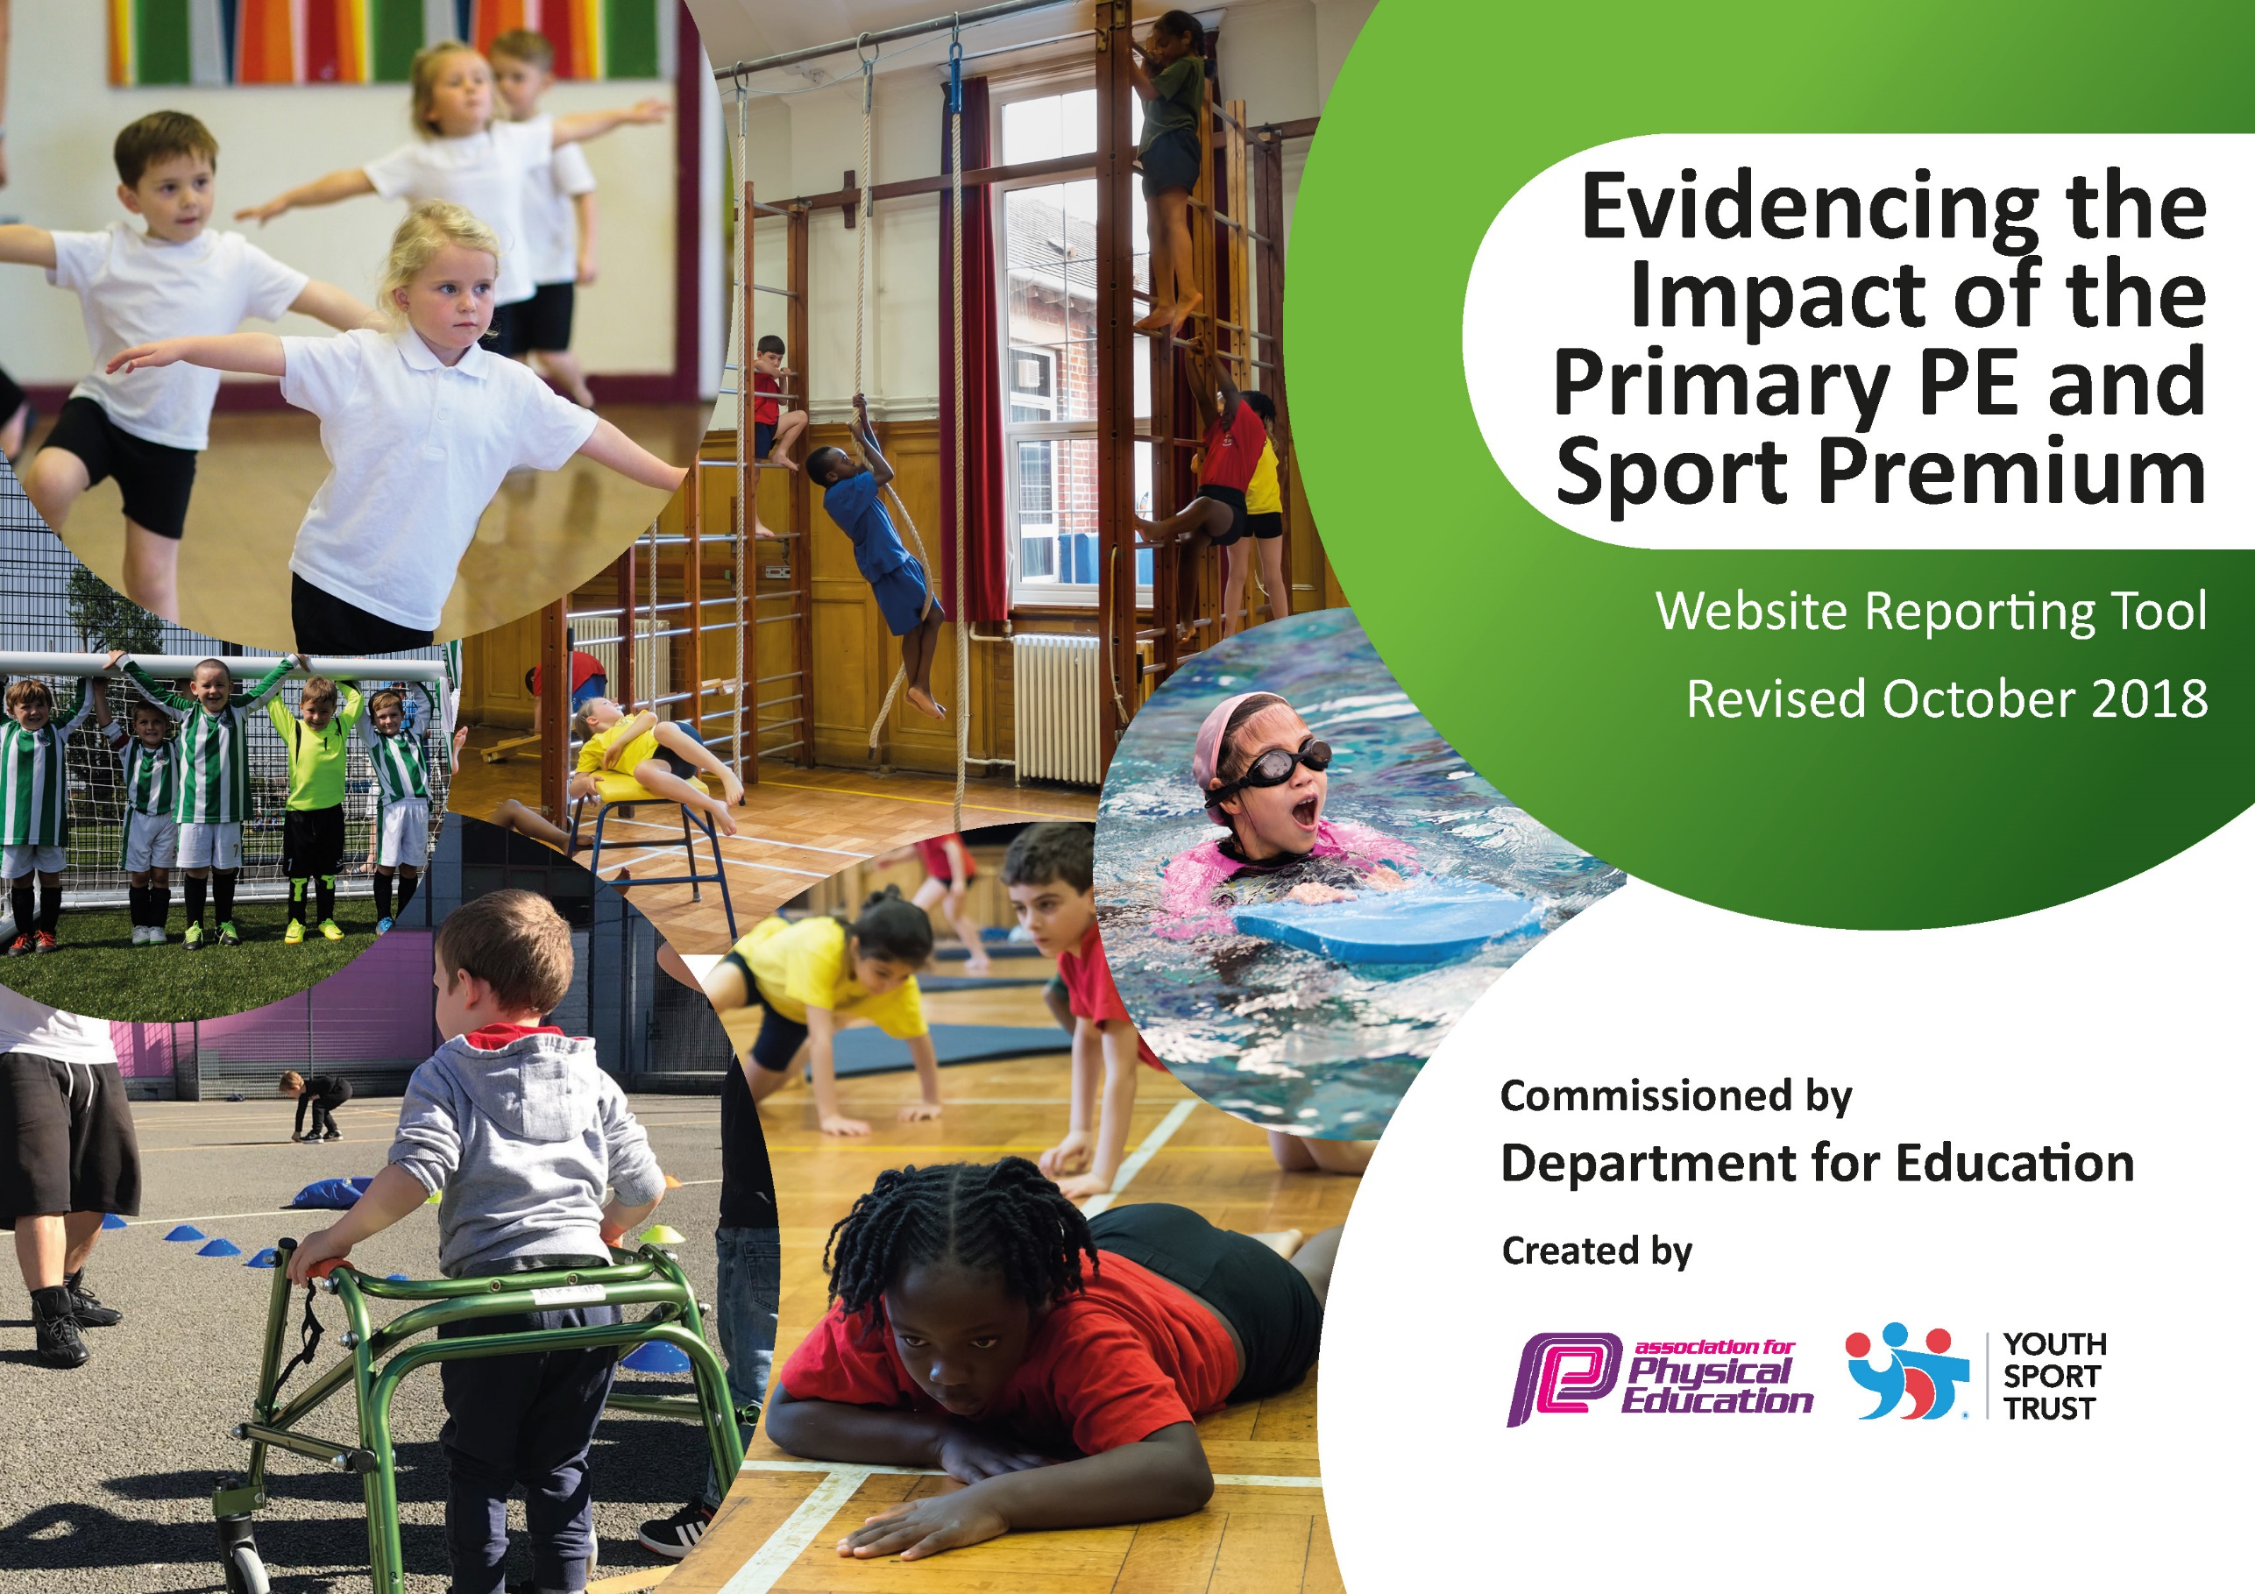
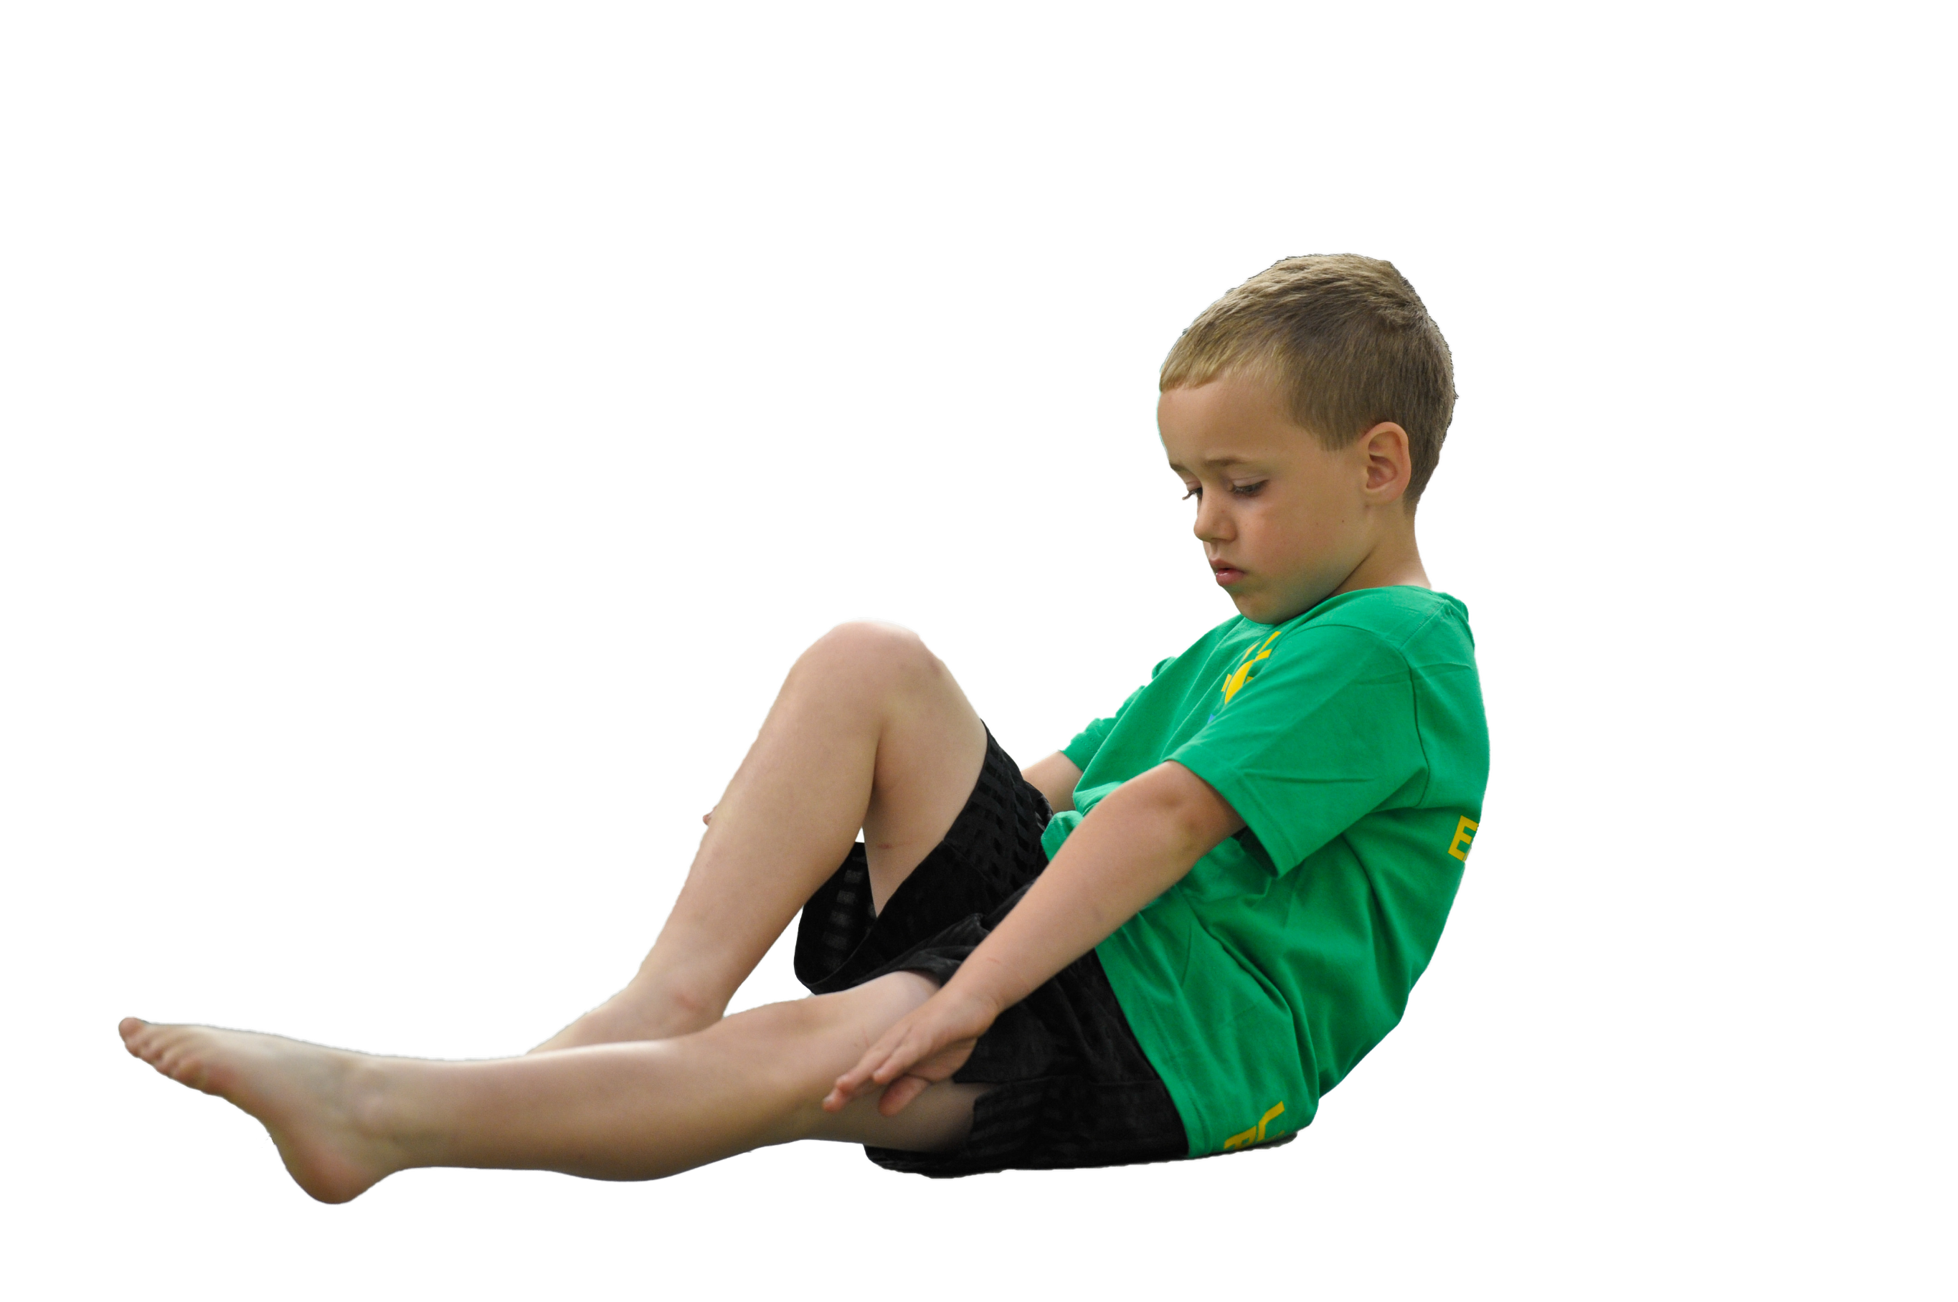
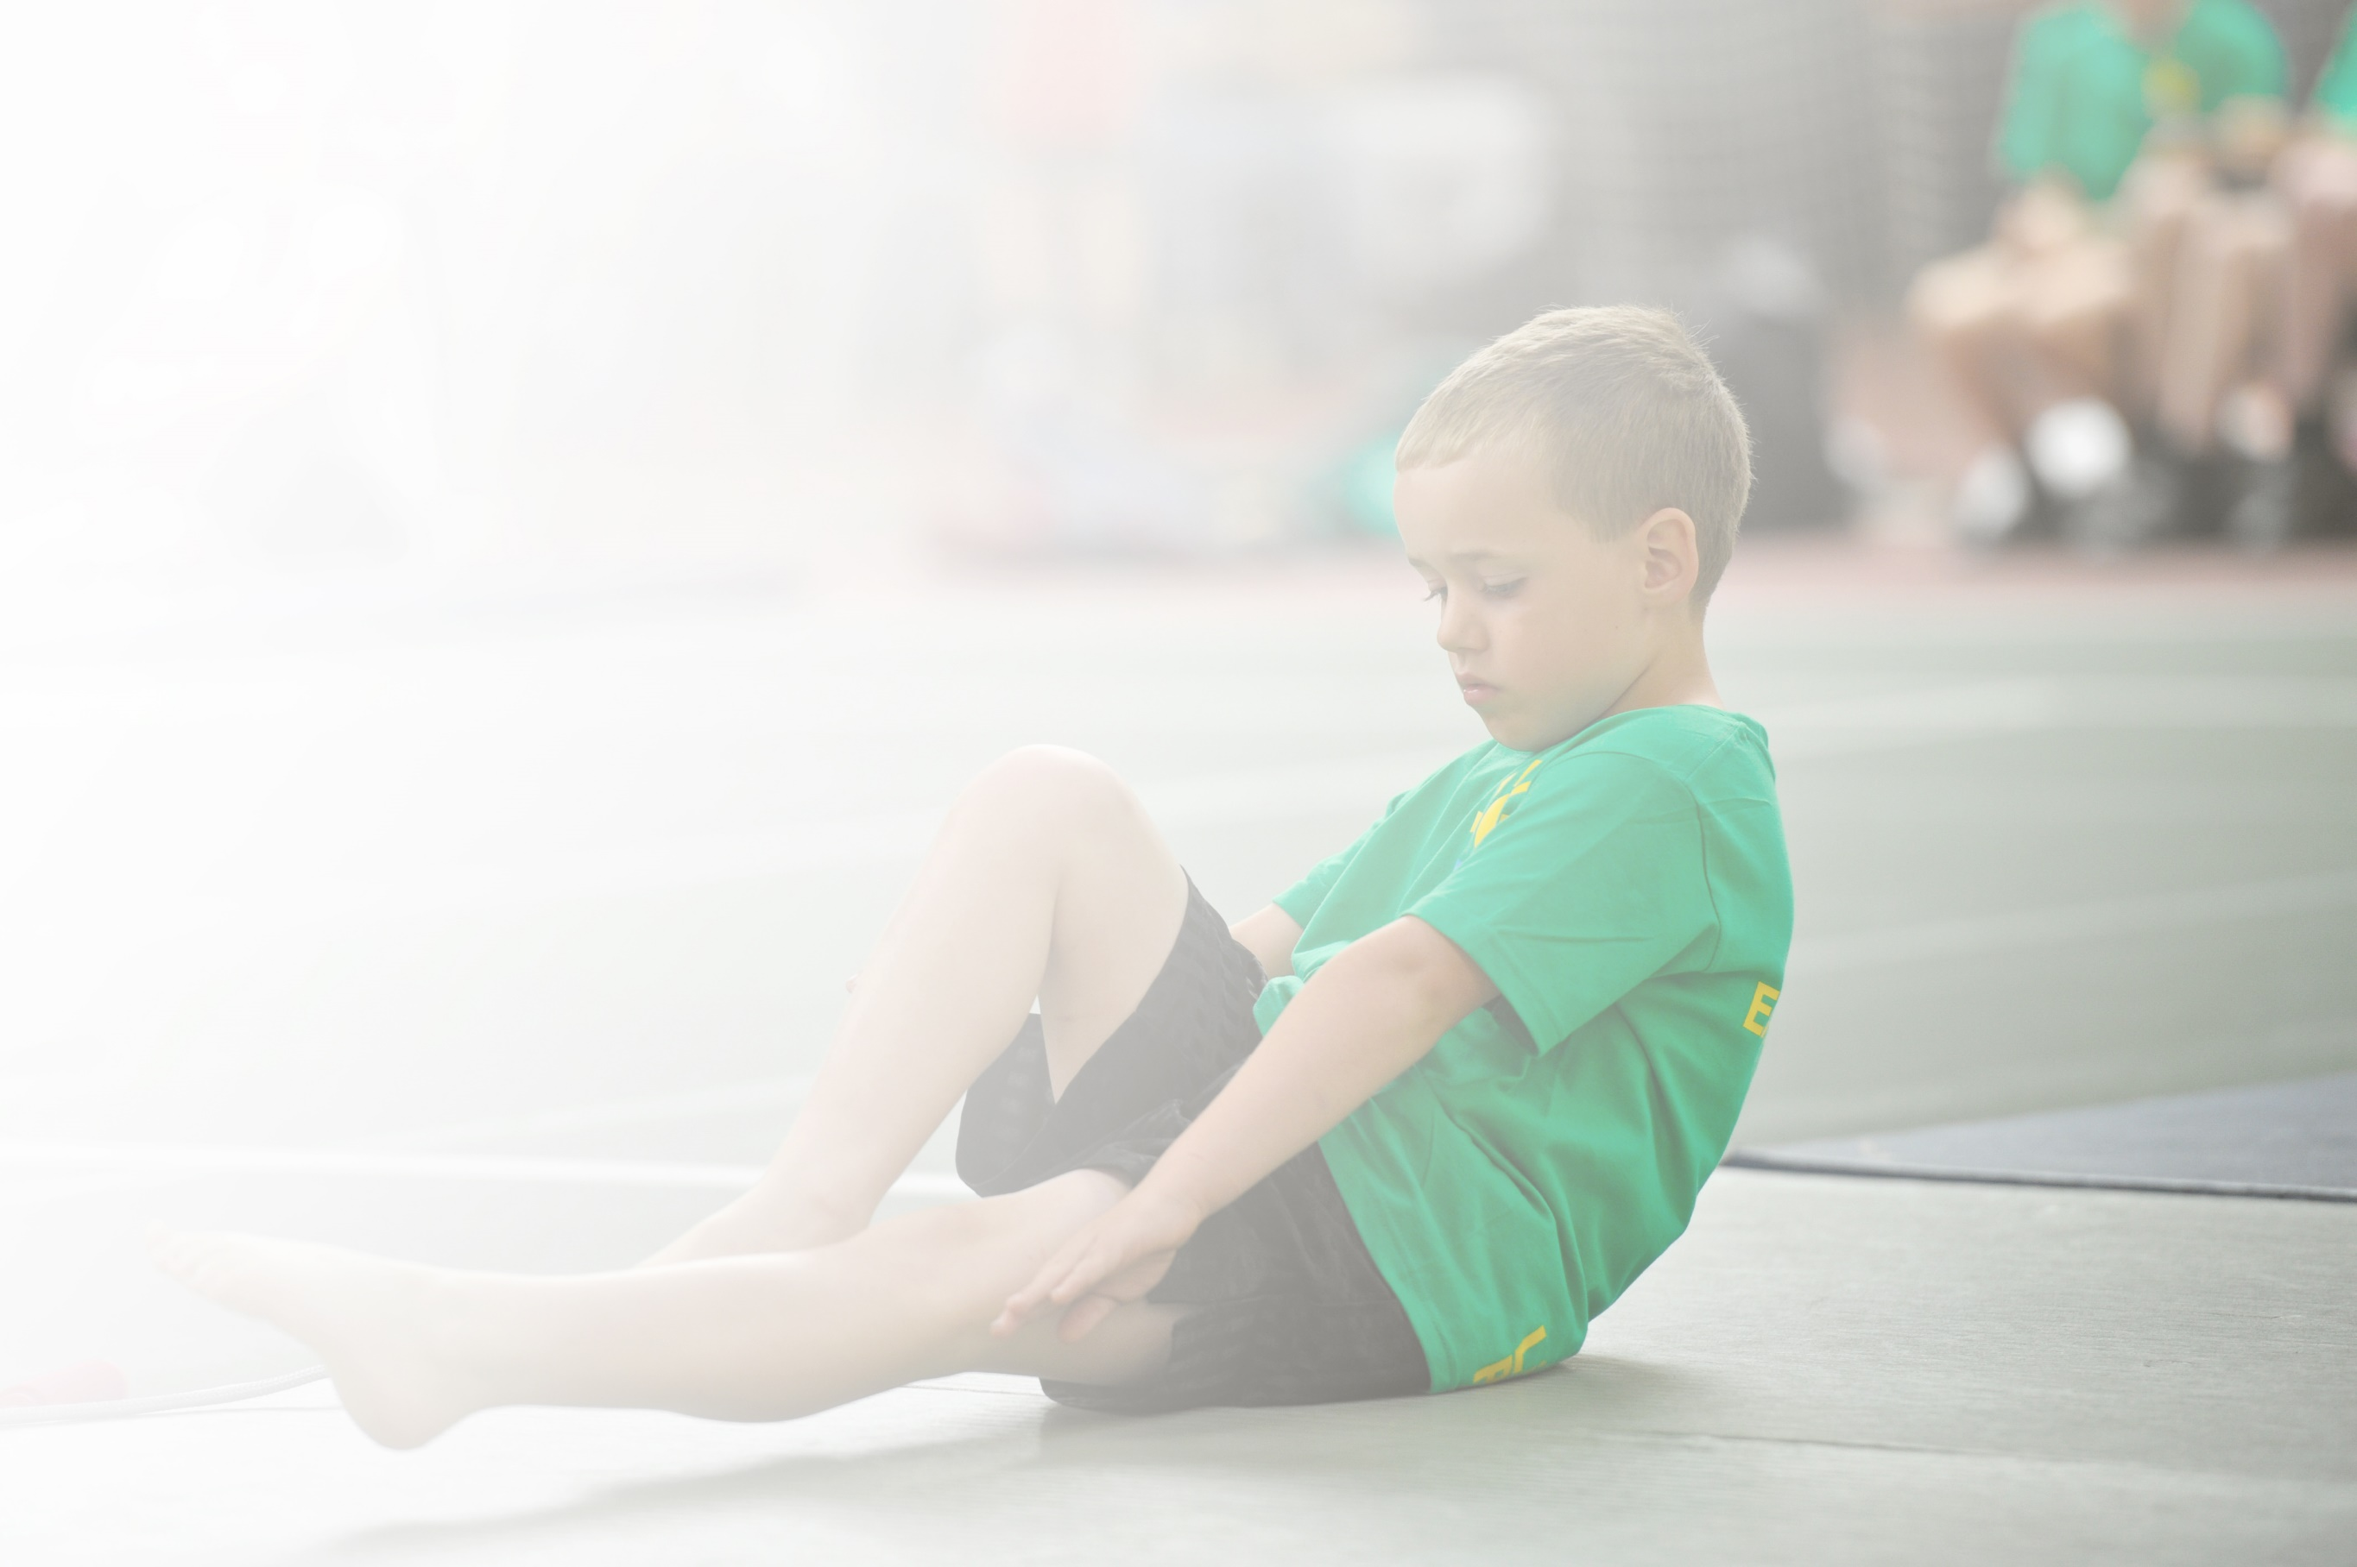
Schools must use the funding to make additional and sustainable improvements to the quality of Physical Education, Sport and Physical Activity (PESPA) they offer. This means that you should use the Primary PE and Sport Premium to:

- Develop or add to the PESPA activities that your school already offer
- Build capacity and capability within the school to ensure that improvements made now will benefit pupils joining the school in future years

Please visit gov.uk for the revised DfE guidance including the 5 key indicators across which schools should demonstrate an improvement. This document will help you to review your provision and to report
your spend. DfE encourages schools to use this template as an effective way of meeting the reporting requirements of the Primary PE and Sport Premium.

We recommend you start by reflecting on the impact of current provision and reviewing the previous
spend. Under the Ofsted Schools Inspection Framework, inspectors will assess how effectively leaders use the Primary PE and Sport Premium and measure its impact on outcomes for pupils, and how effectively governors hold them to account for this.

Schools are required to publish details of how they spend this funding as well as on the impact it has on pupils’ PE and sport participation and attainment by the end of the summer term or by 31 July 2019 at the
latest.
We recommend regularly updating the table and publishing it
on your website throughout the year, as evidence of your
ongoing review into how you are using the money to
secure maximum, sustainable impact. To see an
example of how to complete the table please
click HERE.

Support for review and reflection - considering the 5 key indicators from DfE, what development needs are a priority for your setting and your students now and why? Use the space below to reflect on previous spend, identify current need and priorities for the future.

Key achievements to date: | Areas for further improvement and baseline evidence of need:
- Teacher confidence in teaching PE increased CPD given for target areas.  - Increased number of children accessing extra-curricular sports clubs (after school and during lunch times).  - Development of effective Sports leaders (and play time leaders).  - Development of more links with outside clubs (and other school sporting communities).  - Access to more competitions which has allowed more children to be involved in Sports - Better links with Rother Valley schools and sports clubs.  - More opportunities to compete in level 1 and level 2 sports competition.  - Sports leader undertaking training for level 5 PE (higher quality of PE planning and delivery across year groups).  - Sports hall (better use and marking more appropriate).  - Applications for Quality start and School Games mark.  - Wider variety of sports offered (for both competition and to encourage wider variety of children to attend). | - Swimming provision for KS2 Pupils  - Raise involvement in extra-curricular sport by providing early morning and lunch time sports opportunities- increase quality and efficiency of organized activities during break and lunch times.  - Increase engagement of less active children (Ks2 – based on fitness baseline tests) in regular sport.  - Increase enrichment and participation opportunities for all of pupils in KS1.  - Increase awareness and understanding of healthy lifestyles and activities with upper KS2 pupils (KS1/KS2 Physical fitness day).  - Engagement of all children in regular physical activity in order to target the 30 minutes a day.  - Assessment in PE.

Meeting national curriculum requirements for swimming and water safety
What percentage of your current Year 6 cohort swim competently, confidently and proficiently over a distance of at least 25 metres?  N.B. Even though your children may swim in another year please report on their attainment on leaving primary school. | 81%
What percentage of your current Year 6 cohort use a range of strokes effectively [for example, front crawl, backstroke and breaststroke]? | 81%
What percentage of your current Year 6 cohort perform safe self-rescue in different water-based situations? | 51%
Schools can choose to use the Primary PE and Sport Premium to provide additional provision for swimming but this must be for activity over and above the national curriculum requirements. Have you used it in this way? | Yes

Action Plan and Budget Tracking
Capture your intended annual spend against the 5 key indicators. Clarify the success criteria and evidence of impact that you intend to measure to evaluate for students today and for the future.

Academic Year: 2018/19 | Total fund allocated: £28,729 | Date Updated: 9th April 2019
Key indicator 1: The engagement of all pupils in regular physical activity – Chief Medical Officer guidelines recommend that primary school children undertake at least 30 minutes of physical activity a day in school |  |  |  | Percentage of total allocation:
 |  |  |  | 4.21%
School focus with clarity on intended impact on pupils: | Actions to achieve: | Funding allocated: | Evidence and impact: | Sustainability and suggested next steps:
Opportunities in place to ensure that all children receive 30 minutes of physical activity each day in school;  - Skip2Bfit  - Wake up shake up | Development of playground equipment and play time leaders so that there is a variety of activities children can take part in.  Ensure that play time leaders and Sports Leaders are helping during break and lunchtime in terms of running activities and clubs.  Develop active learning in other lessons.  Introduce Skip2BeFit so all children are undertaking physical activity as part of the 60 minutes a day.  Discussion with whole school through assemblies. | £258.25 WUSU  £951.90 (S2BF) | More active playtimes.  Enriched lunchtimes with more children taking part in sporting activities (Cricket, Football for example).  Encourage active lessons to ensure that there are some mintes towards 30 minutes in school day – encourage personal best (friendly competitive nature) and allow children to have a skipping rope each to enhance sports provision throughout the school day (and outside of school).  Varied sports clubs on offer – Skip2Bfit with personal best target and display to aid children to get better and give themselves a target (certificates also given out). | Liaise with Sports Leaders and Lunchtime supervisors to develop more activities at lunchtimes.  Develop use of playground area with more equipment and a wider variety of sports equipment on offer (activities led by playtime/ Sports leaders).  Maintain use of Sports Leaders at break and lunchtimes.  Provide each child with skipping rope to engage in Skip2BeFit. Ensure that all classes have access to a sports pack for use at break times.  Introduce a breakfast sports club.  Skip2Bfit firmly embedded in the school day and ensure children’s use of their OWN skipping rope.
Key indicator 2: The profile of PESSPA being raised across the school as a tool for whole school improvement |  |  |  | Percentage of total allocation:
 |  |  |  | 33.90%
School focus with clarity on intended impact on pupils: | Actions to achieve: | Funding allocated: | Evidence and impact: | Sustainability and suggested next steps:
Application for the School Games Award (KS2). Leading to review and evaluation of the quality of PE and sport in school. | Contacted Barry Meany (SGO) and indicated interest in applying.  Attend training at Petworth Primary in application process and undertake a critical in depth self-review of the school delivery of PE.  Complete form and arrange a validation visit.  Book staff meeting to showcase the award and plan to have pupil and parent conferencing (announcing award to parents/ carers).  Communicate and encourage press coverage for this. | £300 (to be confirmed) This will include cost of award and appropriate supply cover for meetings and to complete the application. | This award focusses on the actual impact that high quality PE/Sport delivery has on children which should result in a far greater focus on outcomes rather than just provision which in turn will motivate children to always do better having an impact on participation levels.  Sports Leaders running lunchtime clubs and activities for a range of age group. Targeting children who are unable to attend after school.  Friendly competitiveness – understanding of how to be a true sportsperson. | Working document with clear areas for development identified; areas to be addressed over the next three years.  Sports Leaders to run lunchtime clubs and activities for a range of age groups. Targeting children who are unable to attend after school.
Application for the Quality Start Award (KS1). Leading to review and evaluation of the quality of PE and sport in school. | Complete form and arrange a validation visit.  Book staff meeting to showcase the award and plan to have pupil and parent conferencing (announcing award to parents/ carers).  Communicate and encourage press coverage for this. | £300 (to be confirmed) This will include cost of award and appropriate supply cover for meetings and to complete the application. | This award focusses on the actual impact that high quality PE/Sport delivery has on children which should result in a far greater focus on outcomes rather than just provision which in turn will motivate children to always do better having an impact on participation levels.  Sports Leaders running lunchtime clubs and activities for a range of age group. Targeting children who are unable to attend after school. | Working document with clear areas for development identified; areas to be addressed over the next three years.
Grounds maintenance – cutting school field and painting lines (outside as well as in the new sports hall – flooring). This has/ will continue to enable a variety of sports both in and outdoors. | Contact Burleys and ensure that line paintings happen to maintain school field and in preparation for Sports days. | £7,670 (including new gym hall flooring) | Increasing number of sports related clubs being offered for children across KS1 and 2.  Growing number of children involved in competitions.  Varied programme of sporting opportunities. | This has/ will continue to enable a variety of sports both in and outdoors.  Book with SBM each year; ensure that sports markings take place.
Sports Coaching (SCS); Allowing school to provide CPD opportunities for staff and a specialist coach worked with three teachers within school (specific focus for each teacher). | Co-ordinator to offer workshops to staff in order for them to identify areas for them to develop.  Identify areas in which staff need training and provide support that is needed with planning provided as a base to help them.  Discuss planning and termly overview with SCS (try to ensure that skill is a focus as well as team games).  SLT – have some time observing to see progress in delivery of PE.  Pupil conferencing. | £1,470 | Increased subject knowledge and confidence amongst staff which is having a positive impact across school. Staff also leading after school clubs in their area of training.  SLT – have some time observing to see progress in delivery of PE.  Pupil conferencing. | SLT beginning to see raised profile in PE and Sport and are committed to supporting these areas.  Children enjoying their PE session and speaking more fondly of their sessions with teachers being more confident to deliver, lead and be involved.

Key indicator 3: Increased confidence, knowledge and skills of all staff in teaching PE and sport |  |  |  | Percentage of total allocation:
 |  |  |  | 10.32%
School focus with clarity on intended  impact on pupils: | Actions to achieve: | Funding  allocated: | Evidence and impact: | Sustainability and suggested  next steps:
Subject leader undertook afPE Level 5 accredited course (March – October) in order to up-skill her own knowledge and understanding so she can confidently disseminate to all staff, therefore increasing their knowledge and confidence.  AP: HLTA or other to undertake the afPE Level 5 accredited course in order to up-skill and raise awareness and understanding of the crucial role support staff play in raising standards. This was disseminated to all support staff in school. This may also see the Sports/PE leader attend the afPE Level 6 accredited course (see impact above). | Enrolled in the delivered afPE course (Level 5) and cover provided as required.  Liaised with SLT to ensure that there is staff meeting time allocated to share learning and next steps with staff (governor/ governors to be invited to this).  Provide cover so that HC can team teach/ observe all members of staff at least once. | £1,001  (additional costing of x6 days supply @ £150)  Transport costs @ £54.00  £1,955  Cover to monitor staff delivery by HC. | - As a result of good leadership in the subject and confident and knowledgeable staff, all pupils have and continue to make good or better progress, building on prior achievement.  - Increased confidence, self-esteem and a real desire to learn. The enjoyment of PE increased participation in wider activities (impact on % of pupils attending one or more sport based clubs)  - Development of co-operation/ working in groups/ desire to learn impacted right across the whole curriculum and standards improved significantly.  - Fewer non-paticipants. | Subject leader will be allocated ongoing staff meeting time (hopefully once per month) together with slots in professional development days to ensure all staff are kept up to date and that new staff are brought up to date. All staff to be reminded of expectation of delivery of PE.  Suggest some TA development (level 5) to help support class teachers and ensure that all children irrespective of their special educational needs and disabilities continue to make excellent progress in line with their prior learning and ability.
AP: Employ a member of the afpe Health and Safety team to deliver a workshop (October) for all staff in Safe Practice using the afPE publication as a basis for risk assessment and safety in all areas of activity both in the curriculum and in out of school clubs. | Contact afPE office and book a full day workshop in September/October with one of the H&S team during one of the 5 allocated Profession development/ learning days.  N.B. Possible that further training will need to take place if further guidance is published. | £900 including money reserved for purchase of new Safe Practice book. | - All staff should feel confident in ensuring all safety requirements are met and as a result all pupils feel safe and secure; this should encourage them to challenge themselves to go the extra mile and therefore improve their overall attainment.  - Feel secure in the school environment impacting on whole school improvement as children develop the ‘can do’ attitude and a willingness to try harder. Will develop a pupil survey to help evidence the ‘feel good factor’. | Subject leader to ensure that staff are kept up-to-date through staff meetings and dissemination of information that is readily available on the afPE website or through contact with the H&S team (open to all members – see comment about joining below).
Join afPE (School membership) to ensure access to specialist and expert support, keeping the school fully up to date. | Access membership information on afPE website and ascertain relevant information regarding cost/ benefits etc.  Speak with other Rother Valley Schools to get advice.  Pupil conferencing asking about physical activity outside of school (including parent/ guardian/ grandparent involvement in physical activity outside of school). | £111 | - Children should benefit from knowledgeable and confident staff who will be kept up-to-date with all developments. Subject leader, staff and children should keep ahead of developments.  - Children should be able to articulate the difference between PE, Sport and Physical Activity.  - Pupil conferencing asking about physical activity outside of school will hopefully indicate involvement of parents and more involvement from children. | Membership to be purchased and then renewed each year from the school budget if PE and Sport funding is discontinued.
Key indicator 4: Broader experience of a range of sports and activities offered to all pupils |  |  |  | Percentage of total allocation:
 |  |  |  | 27.64%
School focus with clarity on intended  impact on pupils: | Actions to achieve: | Funding  allocated: | Evidence and impact: | Sustainability and suggested  next steps:
Replenish PE equipment for lessons and extra-curricular clubs.  Also include:  - Football pitch  - Gym equipment installation  - Football goals (aluminium goals)  - Badminton equipment (including badminton pitch painted on hall flooring)  *Continue to offer a wider range of activities both within and outside the curriculum in order to get more pupils involved (including Sports hall refurb and netball and badminton lines painted in for a further variety of clubs). | Pupil survey/ conferencing to ascertain what pupils like/ sports that they do outside of school and enjoy as well as those they’d like to see inside of school.  Weekly lunchtime and after school clubs to be run by teachers and Sports leaders.  Raise awareness of different sports and to educate the children on the importance of a healthy lifestyle.  Week organised that is dedicated to PE, Sports and Healthy Lifestyles. | £2,275.45 | Aluminium goals and football pitches have allowed an afterschool girls only Football club that is very well attended by children from Easebourne Primary (75%) as well as other schools in the area.  Wider variety of staff and more staff involved in extra-curricular activities and teachers feel more confident delivering PE/ Sport.  New clubs able to run allowing additional children to attend new club that hadn’t attended before.  Increased amount of personal and team competitive play available (including sports markings that are suitable for play and training up to junior county level).  Build emotional resilience to enable children to meet future challenges in every day life.  Allow teachers access to a wider range of equipment to challenge and stimulate children in PE lessons. | Staff encouraged to work together to share good practice leading to better confidence all round and more staff keen to get involved ensuring that extra activities will not only continue but expand.  School will become less independent on ‘experts’ coming to teach PE/ Sport and use expertise from within the school that the children are comfortable with and able to challenge children appropriately.
Specialist coaches running sessions during curriculum time and during lunch/ after school in order to offer wide range of activities to be able to provide all children with diverse experience of sport. | Hockey Coaching  Football referee academy  Batafon Arts Drumming and Dance academy  Football club  Badminton  Contact coaches and organised days that were appropriate for sporting clubs (lunchtime/ after school).  Invite disadvantaged families to join sports clubs at reduced rate to encourage wider variety of children engaged in sport. | £3,860.50 | Increased amount of personal and team competitive play available.  Build emotional resilience to enable children to meet future challenges of everyday life. | School will become less dependant on ‘experts’ coming in to teach PE and Sport as staff are more confident and keen.  Wider variety of children engaged in physical activity more often. Continue to lead ‘exciting, new and varied’ clubs through expertise of our own teachers.
Specialist dance teacher employed to lead dance classes (after school) with KS2 (allowing teachers to shadow in order to increase confidence of teachers delivering dance and enabling them to see the children’s enjoyment in this club). | VG contacted in order to lead sports club.  Observation proforma/ note taking sheets required and shared with staff (from those that shadow VG). | £720.00 | Enjoyment of children participating in after school club – variety of dance moves (including trampettes – boogie bounce). Allowed children to see dance as a fitness/ physical activity (making connections between Physical activity being fun and rewarding).  Children practising the dances during a break/ lunch time and passing on what they have learnt to other children in the school.
Tree Top Toddler (Tennis within EYFS – using story books as a starter and warm up music for getting ready etc). | Introduce Tree Top Toddlers to EYFS (KS) – using equipment that would normally be introduced in Ks1; teaching chn to throw, catch, hand-eye-coordination from EYFS (music/ stories to help).  Ensure that KS is familiar with resources/ equipment. Ensure that AC is familiar with music/ stories ready to feed them into other activities (story time/ getting ready for Pe etc).  Characters (put characters posters around school to help children engage on their journey through school) | £1,090 | Younger children engaging in wider variety of sports (tennis). Learning to work together at a younger age (teamwork).  Children learning skills such as hand-eye co-ordination and throwing catching when at EYFS and enjoying listening to stories that take them on an adventure where they help the character by doing physical activity.  Further physical activity (minimum 60 minutes a week for EYFS children). | Wider variety of sports for younger children  Encourage more engaged time in physical activity.  Further sport delivery starting at EYFS that should lend them the skills for further engagement in KS1.
Key indicator 5: Increased participation in competitive sport |  |  |  | Percentage of total allocation:
 |  |  |  | 1.3%
School focus with clarity on intended  impact on pupils: | Actions to achieve: | Funding  allocated: | Evidence and impact: | Sustainability and suggested  next steps:
Organise inter-school competitions in various sports to provide more children in competitive sports (MRC School Games Pack and surrounding Rother Valley Schools).  Upper key stage 2 children selected to participate in Gifted and talented workshops; selection of year 5 children participating in Sports Leader training.  Football/ Rounders tournaments | Participate in as many competitions as possible from MRC games pack and other games festivals.  Set up an action plan with sports leaders to run at least one competition each half term.  Build up relations with other sports co-ordinators in the area to arrange inter/ intra school competitions.  Display results, pictures and tables on Sports board.  Give out certificates in Assembly.  Use Sports leaders when doing sports clubs (as a warm up leader etc) and ensure that they are helping the playtime leaders to competently and effectively deliver the sports offered at break/ lunch times. | £250  £80  £50  £380 | Increased attendance in competitions organized by MRC School Games which has led to more children being able to experience taking part in competitions and engaged in wider variety of sports activities.  Each child to represent their Sports day team in competition (including sports day).  Increased participation – team spirit with new sports clothing purchase (tbc). | Continue to work closely with MRC and other cluster schools to develop more competitions.  Competitions to take place every year (termly where possible) and purchase some medals/ trophies to celebrate this.

Extra provision Swimming sessions | *Hire of pool, training of staff  Ensure that children are aware of safety  Ensure that more children are able to perform safe self-rescue within a range of depths | £947 | Increased number of children leaving primary school age being able to perform safe self-rescue and able to swim competently in a range of depths.
 |  |  |  | 3.29% of allocated spending

